Intro: What are we doing?
- Goal – come up with a web application to develop
  - Involves user authentication
  - Interact with some kind of model stored in a database
  - Be visually appealing and have an intuitive user interface
  - Allow the user to input something
    - Which is then used in some way by the application
- Overall, the functionality supported should be rich enough to allow us to demonstrate an understanding of the technologies covered in this course
Design Specification: What needs to be included?
Needs to be prepared within a powerpoint presentation
- Overview of application (1 slide)
  - What does it do?
  - Why is it useful?
- Specification as prioritised user stories (MoSCoW) (1 slide???)
  - Should provide 6-10 user stories
    - Must requirements need to include user authentication, interaction with a database-backed model, and at least one case where the user inputs data which is saved and used by the application
- High-level system architecture diagram
  - Show the main components of the system and any external APIs/services
- An ER Diagram (in compressed Chen notation), along with a description of the attributes in each entity (2 slides max)
  - Model should be relevant to specification and should reflect relationships and constraints appropriately
- Site map showing the site organisation (1 slide)
  - Must also label pages with the Must requirements they support
- A number of wireframes to show main functionality – (2-5 slides)
  - Illustrate the user interface for the core functionality of the system
    - Must cover all Must requirements
- An accessibility plan (1 slide)
  - Should list five web content accessibility guidelines we will consider in our design
    - Each with short phrase describing what it means for web application
  - Five criteria may relate to keyboard/focus, forms/errors, structure/navigation, colour/contrast, feedback/status messages
- Appendix (1 slide)
  - Specify each members contribution in % and what they contributed
  - Page should also include AI use statement
Munro Bagging Application
Overview: a place for hikers/people who want to bag munro's in Scotland to store their experiences and list of Munros

What we want it to have:
  - A list of all the Munro's in Scotland (divide via location in Scotland – suggest following walkhighlands)
    - With height, estimated time to complete, location, difficulty rating
  - Highlight of Munro's the user has already 'bagged'
  - User input on the Munro's they have completed
    - Here they can input their time of completion, date of climb, their star rating, and any comments they wish to share
  - User profile
    - Name
    - How many munro's they've completed
    - How long they've been climbing (years)
    - Favourite Munro
    - Least favourite
  - Search function – to look up a munro

Front Page Idea:
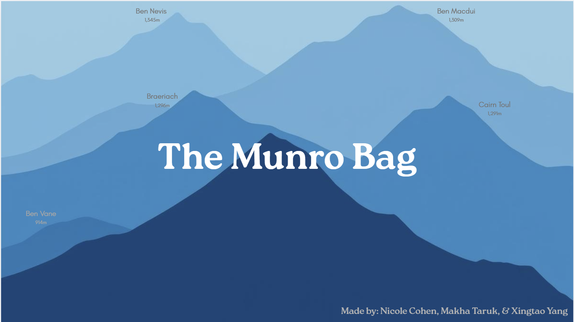Note – this was taken from my canva slides...thinking front page won’t have our names but the four tallest and the shortest munro...then below The Munro Bag, you can scroll down and enter this:
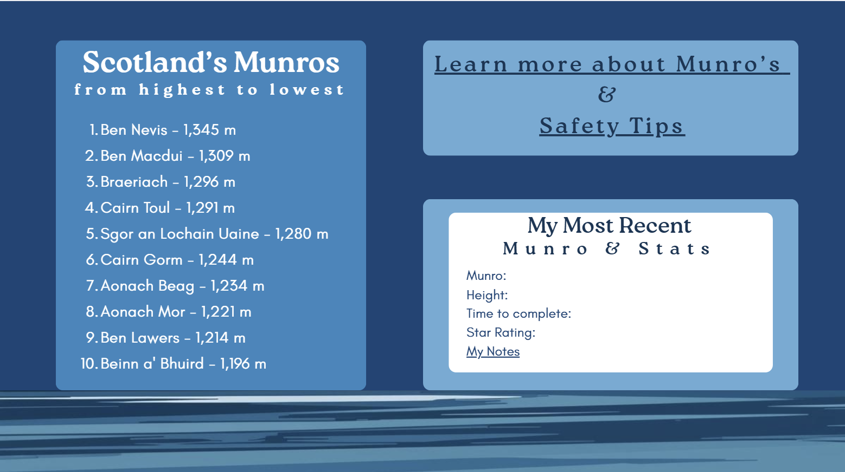Want to give it a feel like you are scrolling down the mountain.

